List of Experiments for Presentations: SIW1 Biology

(n= number of participants, N = number of groups = n/3)

1. Introduction Biology and Germination
Material:
- Seed for germination: e.g. chickpea, mustard, mung-bean, lentils
- N*3 transparent plastic cups or glasses
- N*3 porous cover fabric (Migros)
- N*3 elastics to fix fabric
- N/2 plates for cups to put on
- Few small sticks
- N plastic coffee-spoons
- Drinking water
- N PET bottles
- N permanent felt pens black
- Biscuits salted
Exp 1: Germination
(Work very clean (hand wash), because we will eat the result at the end)
1. Show seeds, look by eye. Observe carefully each seed.
2. Each group takes 3 cups and writes on it group-number and seed name.
3. Each group takes half a coffee-spoon of each seed and puts it into the cups.
4. Add 2 cm of water and wash the seeds. Dispose the water. Repeat this procedure twice.
5. Add 2 cm of water.
6. Cover with fabric and fix it with rubber band.
7. Put it on plate.
Next day:
1. Observe the seeds carefully, compare with dry seed with naked eye and magnifier.
2. Wash the seed twice with drinking water. Dispose water.
3. Put cup upside down on the plate, with little stick beneath, so that all water can run off.
Repeat this twice a day in the morning and in the evening each day.
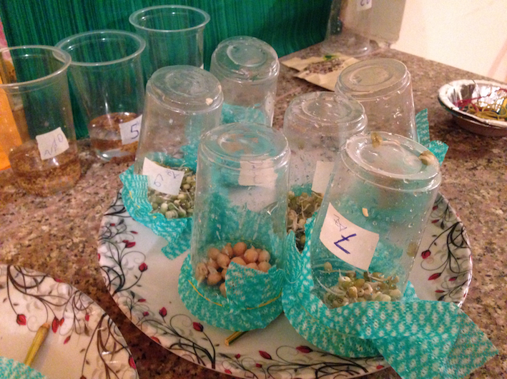

2. Biology Observing
Material:
- Plant in pot for decoration and focus
- Seed for drawing: Sunflower-seeds
- 2 or 3 plates to collect seed (easier to find own seed)
- Thin paper
- n magnifier
- n almonds
- n peanuts
- Ev. visualizer

Exp 2: Drawing Motivation: How to find the own seed?
1. Give one sunflower seed to each student.
2. Instruct to draw one side of the seed bigger than original e.g. length 5 cm on script. (ev. with Visualizer show it on the script).
3. Instruct that they have to find their own seed again.

Exp 3: Magnifier
1. Instruct how to use magnifier.
2. Look at torn paper-edge.
3. Crash almond by biting between the teeth along the fissure.
4. With tongue feel the shape of the almond.
5. Observe with magnifier. What can be seen?

3. Biology Flowers
Material:
- Different small plants with roots (e.g. grass, weed)
- Vegetable with strong vessels (e.g. cauliflower or celery)
- Capillary tubes
- Ink + water
- Flat plate
- N bottom parts of a 3dl PET bottle as small bowl
- > N strips of blotting paper approx. 1 cm width and 7 cm length
- Ev. video camera on stand
- Different flowers (single and composite)
- n magnifiers
- 2 small kitchen knives
- 1 long glass tube
- Coke or black tea

Demo-Exp 4: Suction effect (Transpiration effect)
1. Put Coke or black tea in a cup.
2. With a glass tube suck up the liquid and explain the similarity to Xylem.

Demo-Exp 5: Capillary
1. Put some water in a plate and add 1 or 2 drops of ink, stir.
2. Hold capillary tubes vertical with one end into the ink-water.
3. Observe by eye (students come close) or video projection.

Demo-Exp or Exp 6: Capillary
1. Put some water in a cut off bottom part of a 3 dl PET bottle and add 1 or 2 drops of ink, stir.
2. Put one end of the blotting paper strip into the ink-water; other end hang over the edge of the "bowl".
3. Wait and observe.

Exp 7: Explore vessels
1. Distribute leaves of cauliflower or celery to all.
2. Investigate and find the vessels.
3. With fingernails try to tear off a vessel.
4. Observe it with magnifier.

Exp 8: Explore Flower overall
1. Distribute different flowers to all.
2. Inquire the flower in general and compare the different flowers by eye only.

Exp 9: Explore Flower in details
1. Take one flower.
2. Investigate the flower by eye and perhaps use the magnifier and find the following parts:
stem (1)
sepal (2)
petal (3)
stamen (4)
pistil (5)
3. If time do the same with another flower.
4. Discuss the function of each part.

4. Biology Symmetry
Material:
- 6 posters of flowers (format A3) fixed on the wall
- Masking tape
- n cosmetic-mirrors

Exp 10: Symmetry of hands
1. Compare own 2 hands.
2. Take the mirror in your right hand and observe in the mirror your left hand.
3. Observe: Is the image in the mirror like your left or your right hand?
4. Find objects in the room that are symmetric.

Exp 11: Symmetry of flowers
1. Go to the posters of flowers.
2. With the mirror find out, which flowers have symmetry.
3. Find out how many symmetry axes each flower has.

