List of Experiments for Presentations: SIW1 Optics

1. Nature of Light
Material:
- Pointer stick
- Torch
- Candle
- Stone-plate
- Incense sticks
- Matches
- Fluorescence Star
- Laser red
- Dental floss
- Rectangular object (e.g. book)
- Stand with 2 spot-lamps mounted
- Transformer
- Glass colour filter
- Prism
- Mirror
- Stick taped on chair
- Rotating rainbow disc
- Coloured sheets of paper or clothes

Demo-Exp 1: Fluorescence
1. Keep the fluorescence star first in your pocket, so it was in the dark.
2. Hold it in the light beam of the beamer for 5 sec.
3. Show the star it in a dark corner of the room to the students

Ev. Demo-Exp 2.: Optical fibres
1. Hold the torch lamp on one end of the fibre and show the other end to the students, moving it into different directions.

Demo-Exp 3: Light ray
1. Make light ray visible: It has to hit an object. e.g. hold a sheet if paper in front of the beam of the beamer
2. Point with the LASER to the wall or ceiling -> red spot
3. Hold a sheet if paper in front of the LASER beam and move the paper along the beam. Hold the paper, so the students can see the red spot.
4. To make light visible you need material put in the beam. What we do, is to have many tiny particles in front of the beam -> smoke
5. With the flam of a burning candle on a stone plate lighten a bunch of incense sticks
6. Use the smoke of incense sticks and bring the smoke into the LASER beam
7. Observation: Light path is a straight line, extremely thin

Demo-Exp 4: No distortion of light
Beamer with slide +Laser ray + Smoke + Stick + Dental floss
1. Hold a stick across the light beam of the beamer -> shadow: Light cannot go through
2. Send a LASER ray across the light beam of the beamer -> no shadow (too thin?)
3. Repeat it with dental floss -> shadow
4. Observation: Light rays (beam) can interfere without distortion

Demo-Exp 5: Radiation
One light source radiates in all directions
1. Light candle as one light source, light goes in all directions
2. Detect Light with a sheet of paper in all direction.
3. Go further away with paper -> less bright
4. Compare with a Torchlight -> light cone ev add smoke

Demo-Exp 6: Light cone
1. Put smoke in front of the beam of the beamer with small hole
2. Explain the shape of the light as a cone with narrow angle
3. Change to a slide with big hole and put smoke in front of the beam (cone)
4. Explain the shape of the light as a cone with large angle

Demo-Exp 7: Black Shadow with different sizes
1. Produce shadow of hand in different distances from beamer
2. Observation: Different sizes of shadow on screen
3. Explain: Object and image on the screen have the same shape (2 dimensions only) but different size.
4. Question (Prediction: see approach of science): What is the size of the shadow on the screen of book held into the beam?

Demo-Exp 8: Grey + Coloured Shadows
1. White light number 1 only + stick: Explain setting, ask what happens if light 1 is switched on?
2. White light number 2 only + stick: Explain setting, ask what happens if light 2 is switched on? Will be a shadow, which colour has it, where is it?
3. Both white lights + 1 stick: Explain setting, ask same questions.
4. Repeat step 1. 2. and 3. with coloured lamps. Switch on only short time. Filter-glass may brake due to heat.

Demo-Exp 9: Spectrum of sunlight (if no sun use projector)
1. Stick a white sheet of paper hanging vertical on the stand (-> movable screen)
2. Bring sunray eventually via mirror in darker room, pointes on the prism
3. Catch the rainbow colours on the movable screen with beamer
or if no sun: Use the beamer; in front of it assemble two cardboard boxes with a very small slit
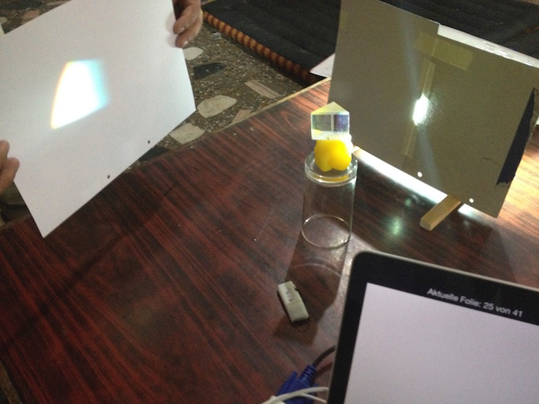

Demo-Exp 10: Mixing all rainbow colours
1. Bring the rainbow disc into rotation. Keep it rotating by pulling the ends of the string
2. Hold rotating rainbow disc into the light beam of beamer -> more or less white.

Demo-Exp 11: Colours of objects
1. Use Light source: Bulb + Filter on stand or beamer with coloured slides.
2. Bring different coloured cloth or sheet of papers and illuminate them
3. E.g. Red cloth appears bright in red light but not in other coloured lights
4. Explain how white light contains all colours and only one colour is reflected by the object

2. Reflection
Material
- Candle
- Stone-plate
- Incense sticks
- Matches
- Aluminium foil flat
- Aluminium foil crumbled
- White paper
- Black paper
- Grey Paper
- Laser
- Big mirror
- N Small mirrors for students
- Model Cardboard + Normal (Pencil)
- Model Cardboard for Reflection with incoming, outgoing ray and normal

Demo-Exp 12: Diffuse Reflection
Reflection on black paper, white paper, Aluminium foil, mirror
1. Use the beamer beam and hold the different papers etc. so the reflection goes to the classroom ceiling.
2. Observe brightening on the ceiling. The flatter and whiter the paper etc. more light is reflected to the ceiling

Demo-Exp 13: Law of Reflection
1. With the flame of a burning candle on a stone plate lighten a bunch of incense sticks
2. Put the big mirror on the floor all students around
3. Use the smoke of incense sticks and bring the smoke into the LASER ray close to the mirror
4. Let the LASER ray hit the mirror with different angles. Indicate the ray with smoke.
Observe incoming and reflected ray in relation to mirror and the normal to the mirror at the reflection point
5. The same as step 4., but hold the LASER firm and move the mirror.
6. Explain with small protractor what could be measured.
7. Show the normal on the plain of the mirror on a model made of cardboard + Normal with a pencil
7. Show the reflection on a model made of cardboard and wires for Reflection with incoming, outgoing ray and normal

Exp 14: Reflection of sunrays
1. Students go into the sun with small cosmetic mirror and have to point to one given object e.g. door
2. In pairs the students have to point with the index finger the path of the sunray.

Exp 15: Reflection of sunrays into a room
1. Organize groups of 3 students, each has a small mirror.
2. They have to give the sunray from one to the other round corners to illuminate a dark room

Demo-Exp 16: Animation with app.
Ev. Phet with File: bending-light_bo.html or online with Link click on Laser-picture

Exp 17: Symmetry and Mirror
1. Students draw the symmetry of a candle in the script
2. Students check the image by butting the mirror vertical on the symmetry axis.
3. Students put the sharpener or eraser on Mini-mirror on one end and observe the image.

Demo-Exp.: Optional Experiments:
- Burning candle under Water (Candle, glass with water, plexy glass-plate with stands in between)
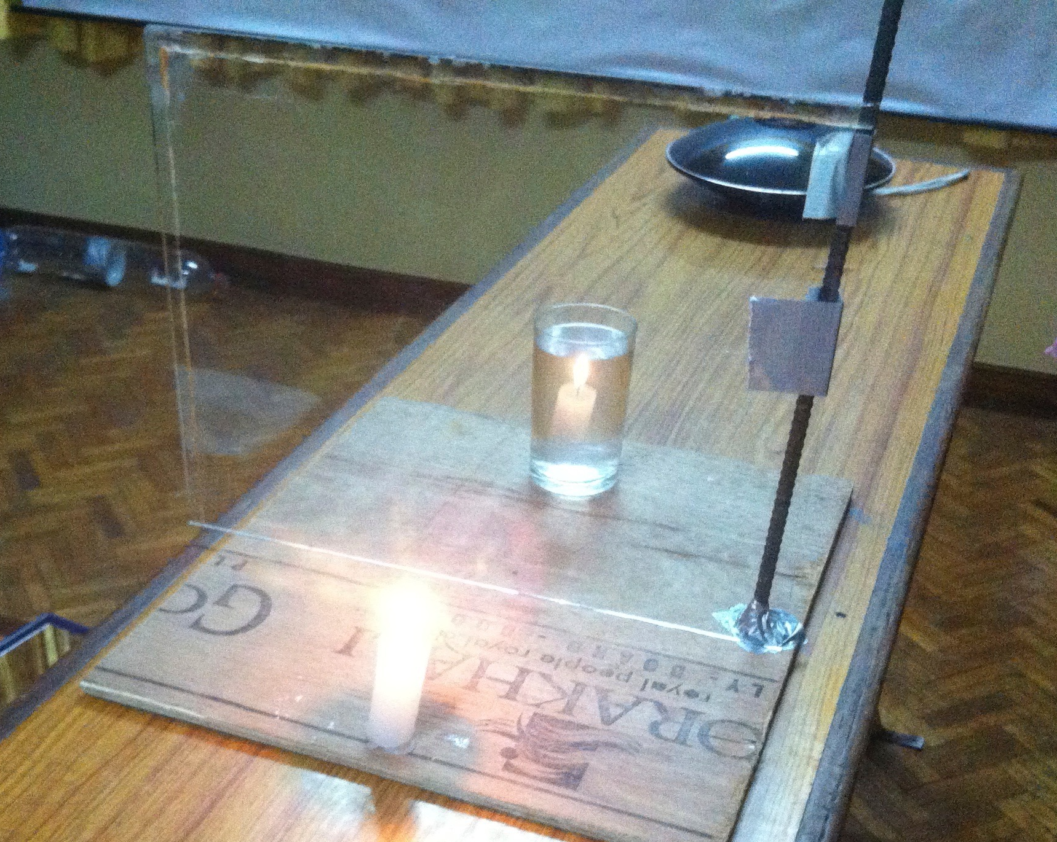

- Triple-mirror with Laser und Smoke (3 flat mirrors taped together as a corner of a box and laser and smoke)
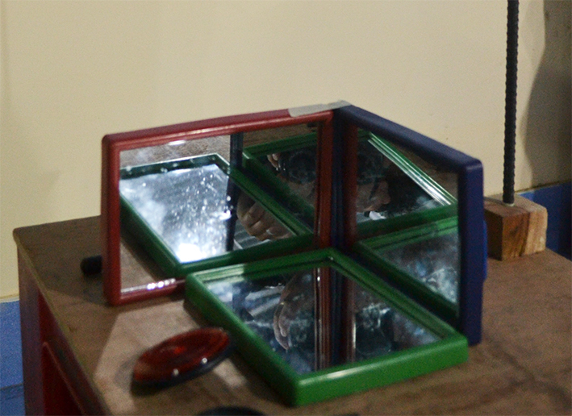

- Rear reflector (Katzenauge)
- Lower half of "Magic Mirror" and burning candle and screen
- Look into soup spoon (both sides) concave und convex
- Cosmetic-mirror
- Magic Mirror

3. Refraction
Material
- Torch
- Candle
- Stone-plate
- Incense sticks
- Matches
- White paper
- Laser + mirror
- Glass filled with water
- Spoon
- 2.5.litter PET bottle part of side cut out filled with water,
- Little mirror
- 2 small logs of wood
- Few drops of milk
- Stand with prism

Exp 18: Intro Refraction
1. Put spoon in glass of water may be several sets
2. Give the glasses to the students

Demo-Exp 19: Refraction at water surface
1. Cut out part of side of a 2.5-litter PET bottle. Cover left on the bottle
2. Lay down the bottle and fix it with wooden logs, so it cannot roll off
3. Put small mirror inside in the middle down
4. Fill it with water
5. Add 1 ev. 2 drops of milk and stir
6. Use the smoke of incense sticks and bring the smoke into the LASER ray close to water surface
7. Let the LASER ray hit the water surface with different angles. Indicate the ray with smoke.
8. Observe incoming and refracted ray in the milky water in relation to mirror and the reflection on the mirror in the water
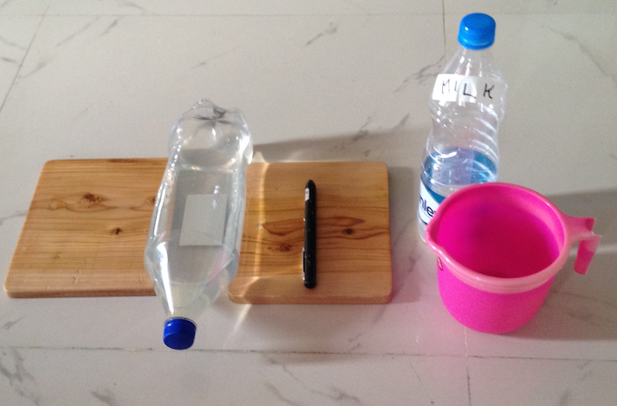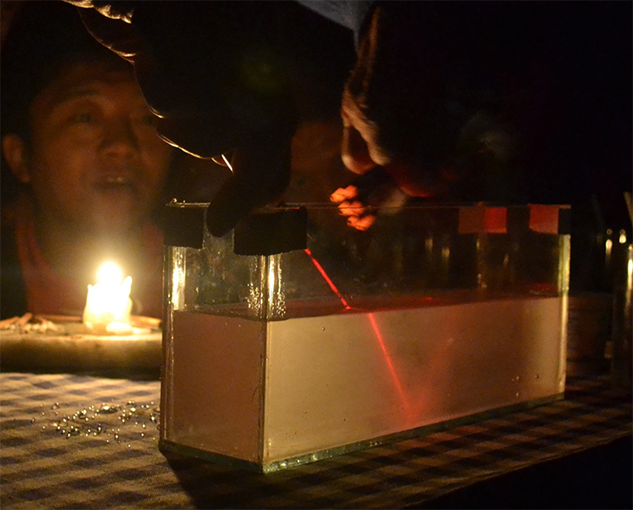

Demo-Exp 20: Animation with App
Phet: bending-light_bo.html

Demo-Exp 21: Refraction at prism
1. Fix the prism high up on the stand
2. Use the smoke of incense sticks and bring the smoke into the LASER ray close to prism surface
3. Let the LASER ray hit the prism surface with different angles. Indicate the ray with smoke.

Optional Experiments:
- Total Reflection
- Optical fibre
- Water flow with LASER

