**Dissection of Fish ཉའི་གཤག་དཔྱད།**

(Instruction for Teachers)

##### 1. Objectives:

- Observe the external and internal anatomy of a fish.

- Name, locate and identify the organs that make up various systems of the fish.

- Identify similaities between fish and humans.

##### 2. How to proceed: The outer organs and the abdominal cavity



2.1.) Examine the fish: Look at its skin; pull out the fins and look at their structures and shape



2.3.) Locate the small hole on the underside of the fish. What is this?





2.2.) Locate the gills. A covering protects these gills. Separate the gills using tweezers. How many gills are there?



2.4.) Cut the fish open from the anus up to the neck using a scissor. Try not to cut too deeply. Stop when it becomes hard to cut. (1) Heart (2) Liver (3) and (4) other organs



2.5.) Pull the adipose tissue (1) and put (2) aside to expose the swim bladder (3), gonads (4) and kidneys (5). The gonads and kidneys ar paired. One of each can be seen on both sides of the swim bladder.

##### 3. Clean belly (body cavity) – Free the vertebral column

When you have identified the inner organs of the fish, fill complete the **worksheet**.

Now empty the abdominal cavity and clean it with water.

Cut away the **head** and keep it on the side for the next step of your dissection.

Eliminate the muscular tissue with the tweezers. Now you can see clearly the ribs and a red organ, the fish’s kidney behind which lays the vertebral column.

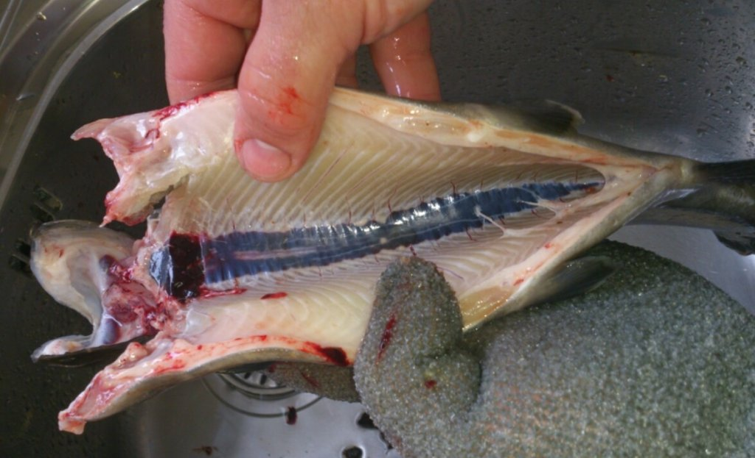

3.1.) In order to take out the kidney cut with your scalpel on both sides lengthwise. Clean again with water. Now you can see the back bone with the many vertebrae and ribs.

3.2.) With a thin stick feel inside the bony vertebral column the smooth inner part, the spinal cord, that is the nervous tissue connected directly with the brain

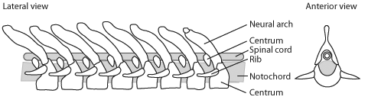

.

##### 4. The head – eye and brain

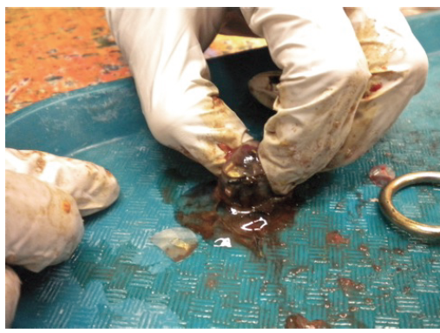

4.2.) Remove the eye from the fish using scissors to cut throughthe optic nerve. Using the scissors and tweezers or needle, cut open the eye. Can you find the lens?

4.1.) Use the scalpel cut under the eye and lift it out. Can you see the difference between the muscles and nerves that are connected to they eye? What is the eye connected to? The skull can be opened to examine the brain.

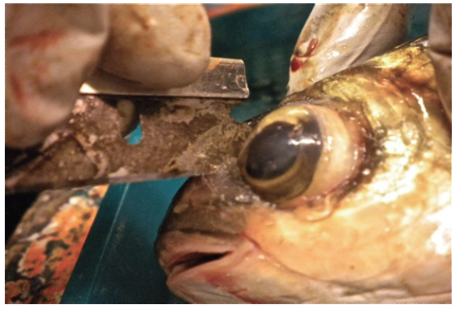

4.3.) **Keep the lens in fresh water for a next lesson about the eye as an organ.**